Adagio- AP (Accounts Payable)
-Invoices tab
-Create New Batch

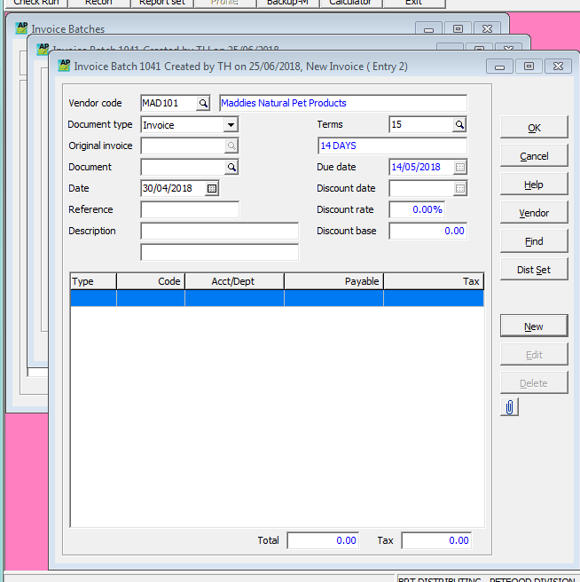
CA pay vend + first 3 letters of Vendor 100, arrow down to find Vend.
US pay vend+ first 3 letters of Vendor 150, arrow down to find Vend.

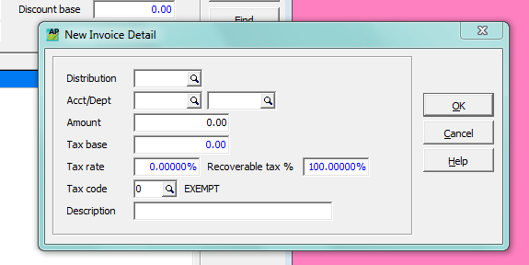
-Stamp invoice posted.

Post Batch when finished.

When tax is on invoice, enter invoice total minus tax, then enter tax as separate entry under tax code.

